Kings Park & Kinds Glen
Winter-Spring 2024 Proposed Classes

Program Description
Come join the fun with Kidcreate Studio! Our amazing art classes are perfect for kids who love laughing and having fun. Not only will they create beautiful masterpieces, but they'll also learn essential art concepts and get to experiment with lots of different art materials. And guess what? We also offer classes for big kids, so everyone from 18 months to 99 years old can join in on the fun! Don't miss out - visit us at www.kidcreatestudio.com to learn more about Kidcreate Studio.

Teacher Arrival Time
Our teachers are all prepared for class prior to arriving at your location. Our teachers arrive 15-20 minutes early in order to set up the classroom. The teachers can start greeting the children 5 minutes before the class time starts. If you require additional time for our teachers to be available for child supervision, please let us know right away so we can accommodate that in our schedule and provide an updated fee for the additional time.

Room Accommodations
Art can be a Messy Business. We highly recommend hosting our art classes in an art room, or uncarpeted room with a sink, and tables and chairs that are washable.

NEW- Senior and Adult Classes
If you are not the correct person to book these classes please let us know who we should reach out to. Thank you in advance!!

Online Registration
If need be, Kidcreate Studio can handle the online registration process for your organization. There will be a slight increase in our fees to do so.

School Age Classes (5-12 years)

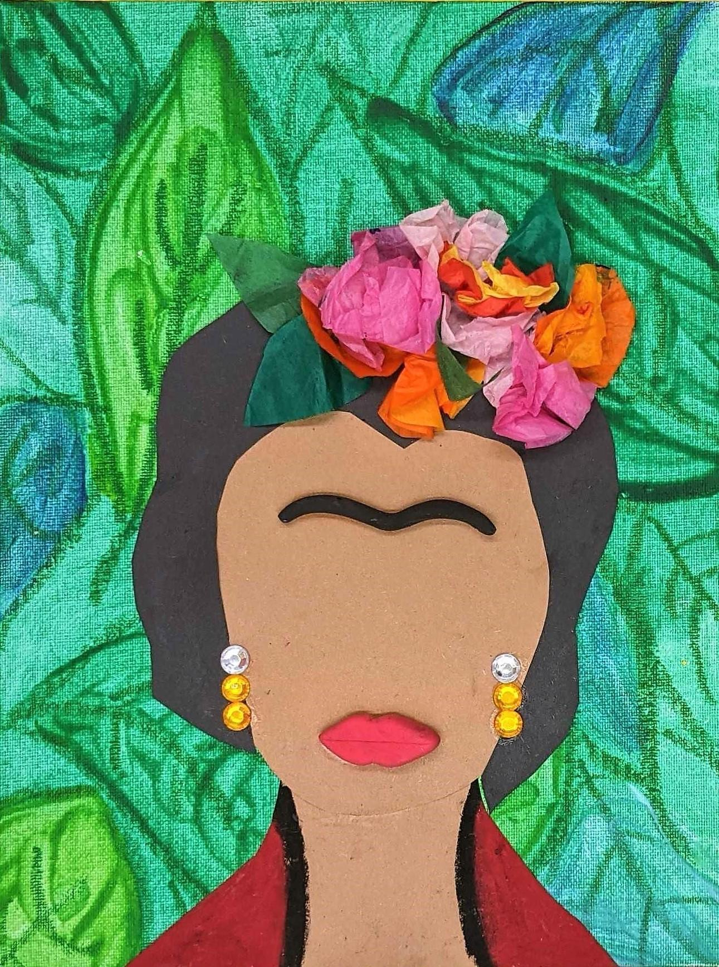
Messes & Masterpieces with Kidcreate Studio (5-12 years)
What’s one thing all great artists have in common? They make a mess, of course! In this class, we’ll create stunning masterpieces while using some of the coolest, messiest art techniques ever. From Frida Kahlo, Picasso, Salvador Dali and more, each messy masterpiece will be inspired by a different master artist. Kids, you better roll up your sleeves, because no masterpiece was ever made without first making a mess!

Location | Date | Time | Cost | Course Number
TBD | TBD(4-6 week session) | 1 hour per class | TBD | TBD
TBD | TBD(4-6 week session) | 1 hour per class | TBD | TBD

Kidcreate Fee | Age | Min/Max | KC #
$72 per child (4 weeks)  $90 per child (5 weeks)  $108 per child (6 weeks) | 5-12 years | 10/25 | 1198

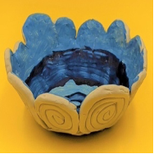
Awesome Art with Kidcreate Studio (5-12 years)
If you think art is awesome, this is the class for you! We’ll explore all the coolest art materials as we learn drawing techniques, create with clay, and paint on real canvas boards. We’ll even create a beach scene out of real candy! Art really is awesome!
Location | Date | Time | Cost | Course Number
TBD | TBD(4-6 week session) | 1 hour per class | TBD | TBD
TBD | TBD(4-6 week session) | 1 hour per class | TBD | TBD

Kidcreate Fee | Age | Min/Max | KC #
$72 per child (4 weeks)  $90 per child (5 weeks)  $108 per child (6 weeks) | 5-12 years | 10/25 | 1187
Drawing Made Easy with Kidcreate Studio (5-12 years)
Have you ever wished drawing was easy? Well in this class, it couldn’t be easier! For each drawing project, students will learn a simple step-by-step method as they draw well-dressed llamas, cute kittens, adorable pandas, and more. Drawing is easy, fun, and anyone can do it- and this class proves it!

Location | Date | Time | Cost | Course Number
TBD | TBD(4-6 week session) | 1 hour per class | TBD | TBD
TBD | TBD(4-6 week session) | 1 hour per class | TBD | TBD

Kidcreate Fee | Age | Min/Max | KC #
$72 per child (4 weeks)  $90 per child (5 weeks)  $108 per child (6 weeks) | 5-12 years | 10/25 | 1213

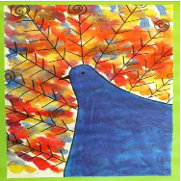
Art Academy with Kidcreate Studio (5-12 years)
Does your child love art? Painting, drawing, clay- it’s all awesome! We will experiment with many techniques, materials and styles as we make snow globes, paint on canvas, create clay characters and more. Come ready to have an artsy good time in this highly anticipated class!
Location | Date | Time | Cost | Course Number
TBD | TBD(4-6 week session) | 1 hour per class | TBD | TBD
TBD | TBD(4-6 week session) | 1 hour per class | TBD | TBD

Kidcreate Fee | Age | Min/Max | KC #
$72 per child (4 weeks)  $90 per child (5 weeks)  $108 per child (6 weeks) | 5-12 years | 10/25 | 1010

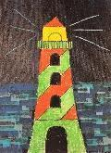
Introductory Drawing with Kidcreate Studio (5-12 years)
Calling all doodlers! Are you ready to take your drawings to the next level? We’ve got the perfect class for you! In this advanced class designed specifically for older artists, we’ll learn and master a simple step-by-step method to truly fantastic drawings. From cute koalas to radiant sunsets to a lighthouse that really glow-in-the-dark, we’ll hone our drawing skills as we create unique masterpieces any burgeoning artist would be proud of!

Location | Date | Time | Cost | Course Number
TBD | TBD(4-6 week session) | 1 hour per class | TBD | TBD
TBD | TBD(4-6 week session) | 1 hour per class | TBD | TBD

Kidcreate Fee | Age | Min/Max | KC #
$72 per child (4 weeks)  $90 per child (5 weeks)  $108 per child (6 weeks) | 5-12 years | 10/25 | 1215
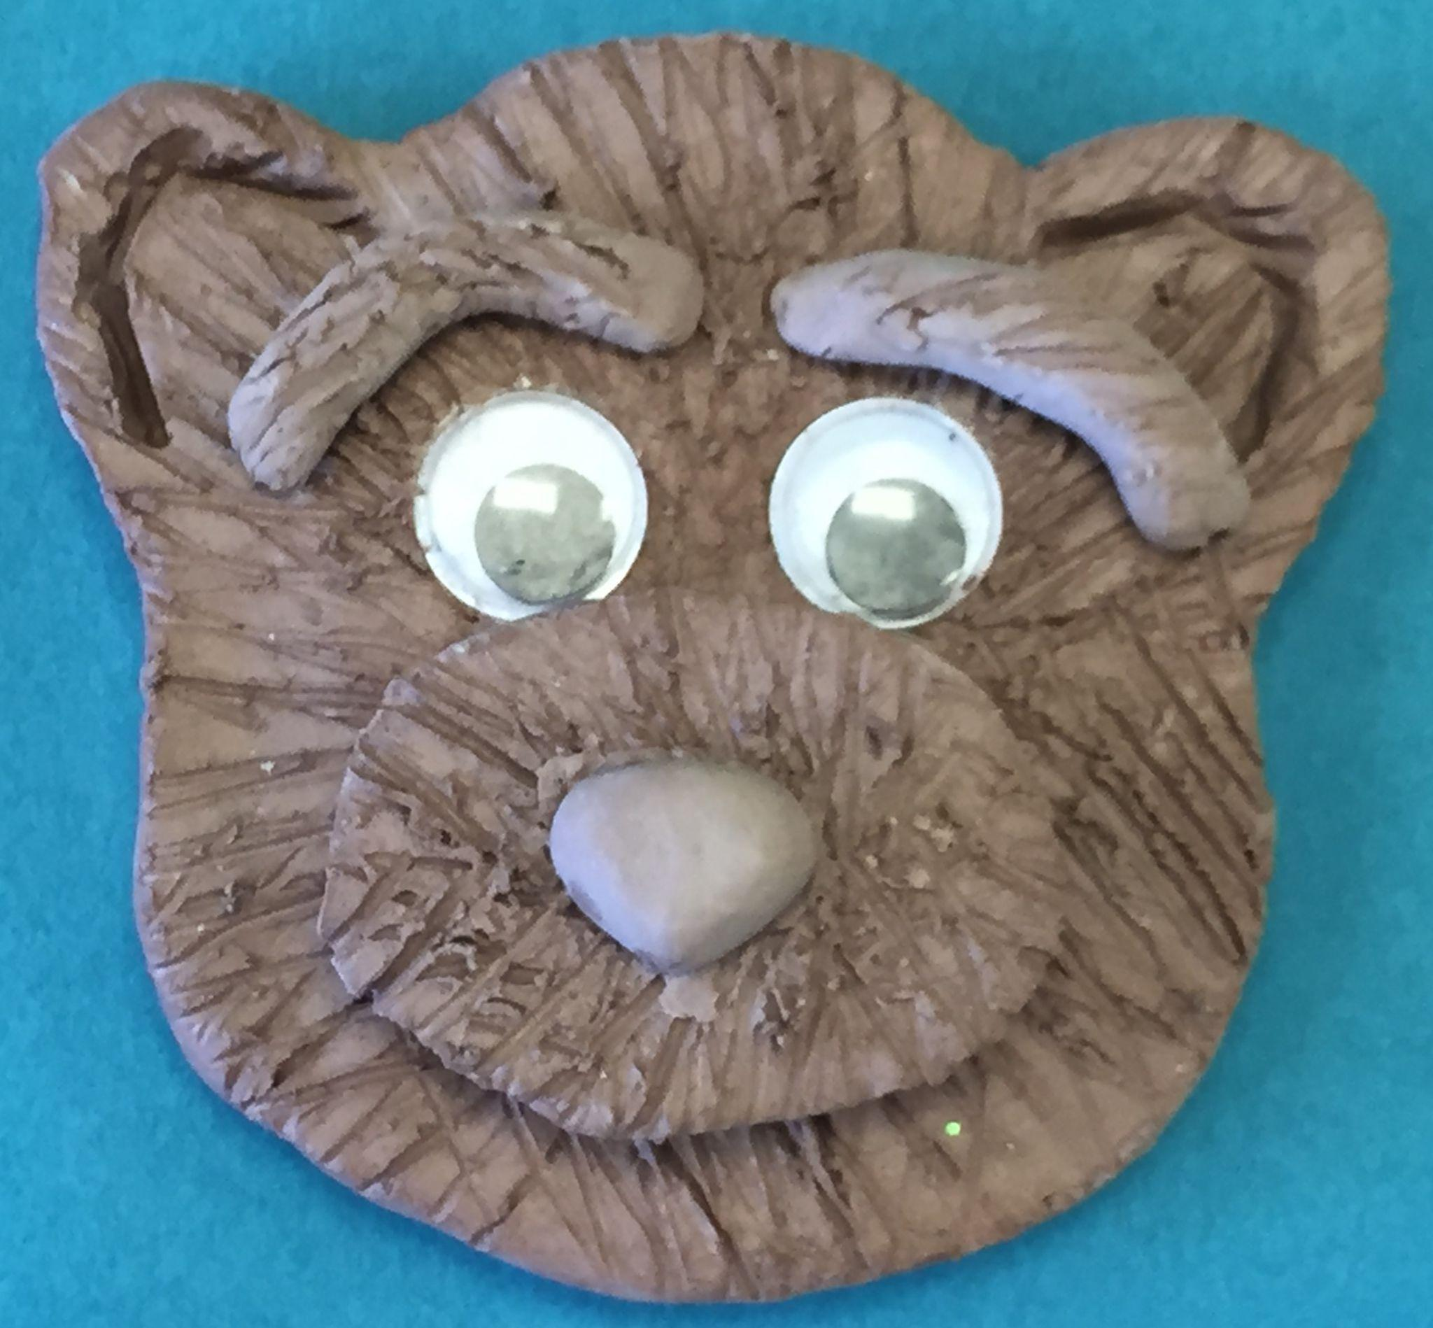
Canvas & Clay with Kidcreate Studio (5-12 years)
Creating with clay and painting on canvas- it just doesn’t get any better than that! In this camp, your child will get to experiment with many different types of art while learning simple step-by-step painting and clay techniques. They will make 3D bears, owls that glow-in-the-dark, a scratch board painting of a cat and so much more! What a great way for your child to explore the incredible world of art! Please pack a nut free lunch, snack and drink for your child.

Location | Date | Time | Cost | Course Number
TBD | TBD(4-6 week session) | 1 hour per class | TBD | TBD
TBD | TBD(4-6 week session) | 1 hour per class | TBD | TBD

Kidcreate Fee | Age | Min/Max | KC #
$72 per child (4 weeks)  $90 per child (5 weeks)  $108 per child (6 weeks) | 5-12 years | 10/25 | 1134

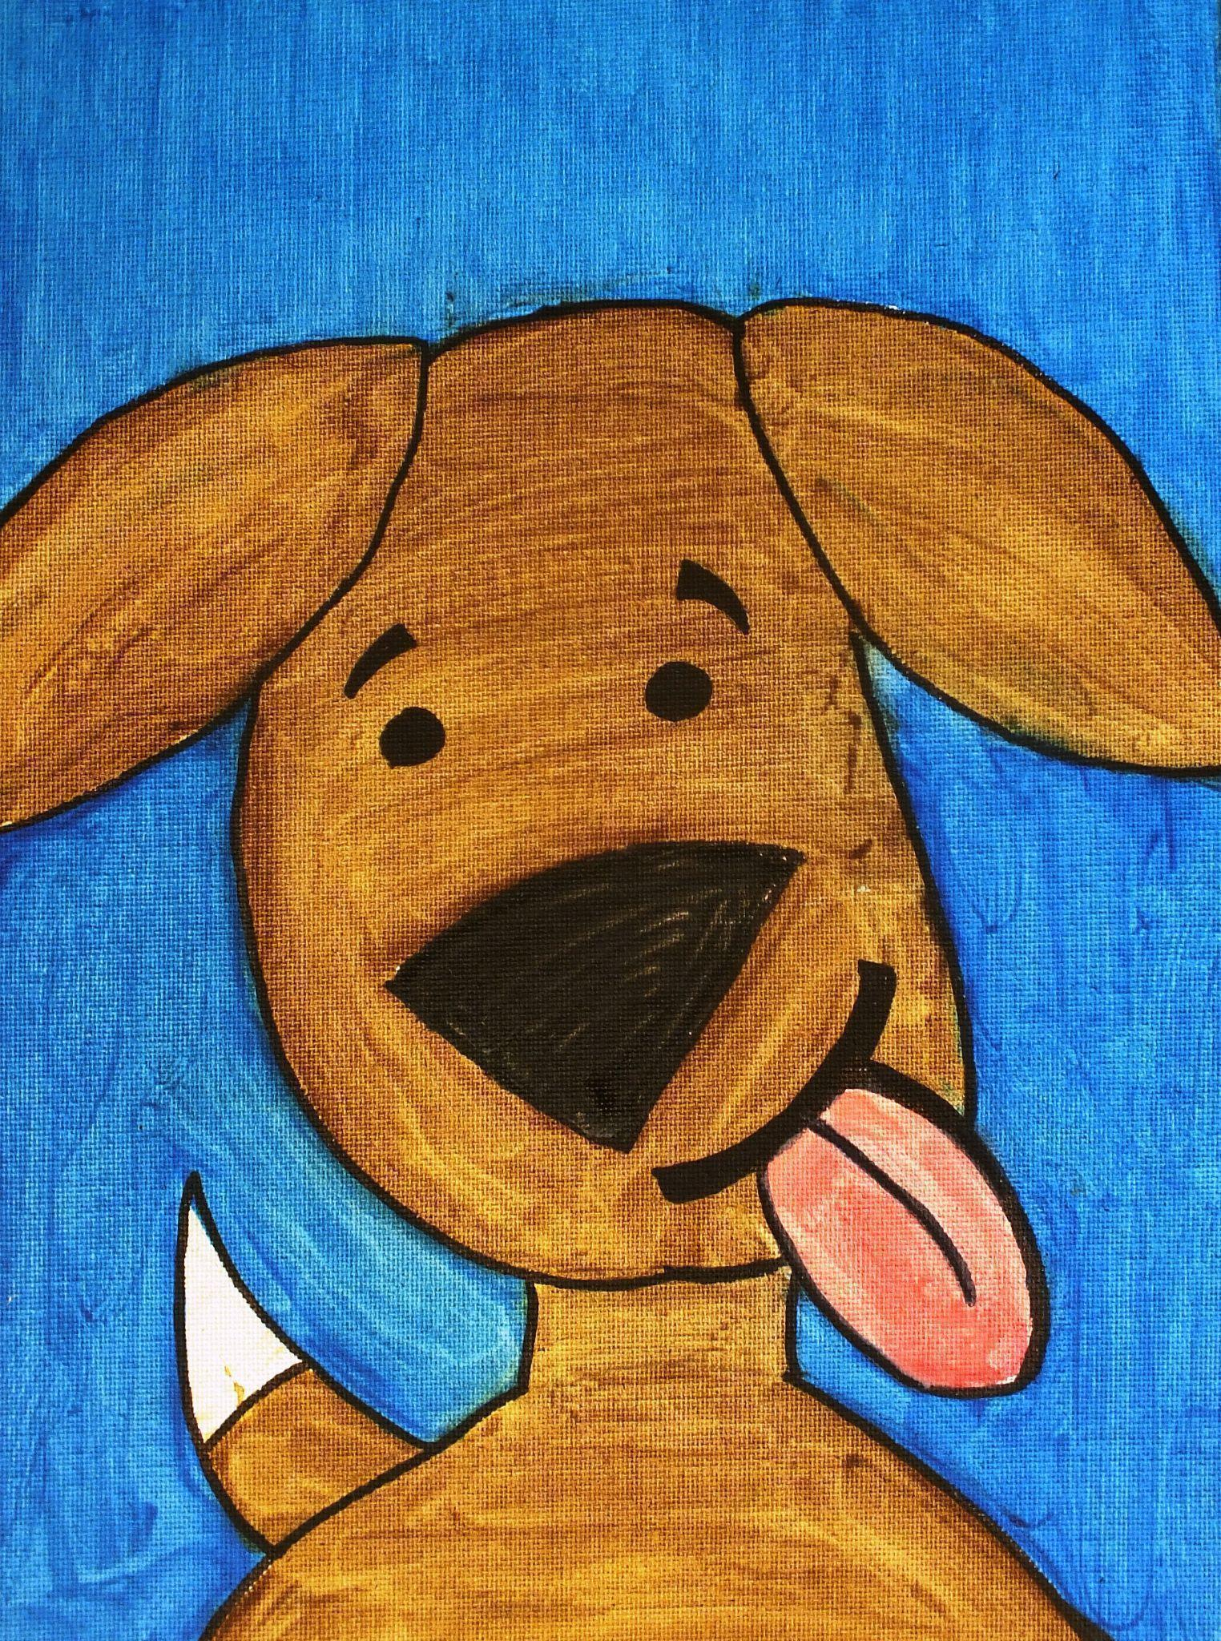
Let’s Draw with Kidcreate Studio (5-12 years)
If it’s drawing, sketching, and cartooning you’re after, then this is the class for you! In this introductory drawing class, we’ll learn basic techniques and principles of drawing as we create puppies, ponies, people, and more. The kids will master a simple step-by-step method that is essential to creating memorable drawings. Each child will receive their own take-home How to Draw booklet! Please pack a nut free lunch, snack and drink for your child.

Location | Date | Time | Cost | Course Number
TBD | TBD(4-6 week session) | 1 hour per class | TBD | TBD
TBD | TBD(4-6 week session) | 1 hour per class | TBD | TBD

Kidcreate Fee | Age | Min/Max | KC #
$72 per child (4 weeks)  $90 per child (5 weeks)  $108 per child (6 weeks) | 5-12 years | 10/25 | 1166

Do-At-Home Art Kits with Online Instruction
Do-at-home art kits with online instructional videos are now available from Kidcreate Studio! These art kits are so much fun; it’s like having your very own private art teacher! The kit contains an easy to follow lesson plan, a link to a correlating online instructional video taught by a Kidcreate Studio art teacher, art materials needed to create one fridge-worthy masterpiece and additional suggestions for online learning that relate to the art lesson. To view all available art kits go to https://kidcreate.com/about/gallery and select Art Kits in the category drop-down. Contact us for more information.

Community Event (18 Months- 99 Years)
Inspire artists, young and old, at your next community event with a Kidcreate Studio art activity station. Art is tons of fun and great for the brain too! It’s a great addition to school carnivals, festivals, dances, fundraisers, or any event that needs a creative, fun boost! A Kidcreate art station is easy. You supply the artists; we supply the curriculum, teachers, art materials, giggles, and grins. We even handle the cleanup! We have tons of project options available. We can even match your event’s theme! Let’s work together to make your occasion extra awesome! To view project ideas go to https://kidcreate.com/about/gallery and select Community Events in the category drop-down. Contact us for more information.
- Fall & Halloween Festivals
- Breakfast with Santa
- Daddy and Daughter Dances
- Easter Egg Hunts
- Art Festivals
- And more..

Group Art Activity Options (3-12 years)
No School Day and Holiday Themed Group Art Activities!
Kidcreate offers two great ways to bring art education to the kids in care programs. You can bring the kids to our studio for a fun art-themed field trip. Or we can send our teachers to you for an art activity right at your location. Our teachers provide a fun, self-esteem building atmosphere where children learn to express themselves through the visual arts. Lessons are 45 minutes to 3 hours long, depending on the age of the children and the project selected. We have 100's of art lessons to choose from, including great holiday-themed projects. The cost varies depending on class length and the number of students participating. To view project ideas go to https://kidcreate.com/about/gallery and select Group Activies in the category drop-down. Contact us for more information.
We can accommodate very large groups with the two above listed classes. If you are not the correct person to contact about these types of classes, we’d love for you to forward this information on to them or give us their contact information so we can reach out to them personally!

